Learn हिंदी (Hindi) interactively with Sounds
By Vedavyasa Rao

Introduction
This tool is designed for the audience such as school going kids or adults interested in learning Hindi language by forming words and later hearing the sounds of the words. The sounds are provided by the courtesy of Googles Text to Speech Synthesizers.
The tool comes with preloaded sounds for vowels and consonants with Matras. These are again generated by the courtesy of Googles Text to Speech Synthesizers.
The tool itself is a single HTML page with JavaScript driving it.
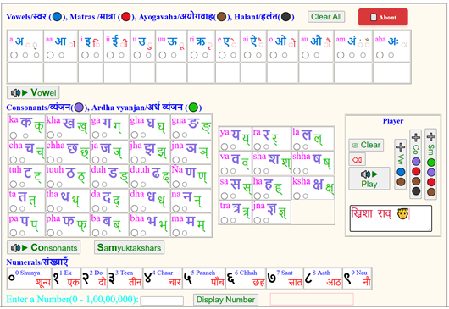

We shall deep dive to understand different aspects of the tool.

Character Groupings
Vowels: अ, आ, इ, ई, उ, ऊ, ऋ, ए, ऐ, ओ, औ, अं, अः
Matras: ◌, ा, ि, ी, ु, ू, ृ, े, ै, ो, ौ
Halant: ्
Ayogavaha: ं,ँ, ः
Consonants:
क, ख, ग, घ, ङ,
च, छ, ज, झ, ञ,
ट, ठ, ड, ढ, ण,
त, थ, द, ध, न,
प, फ, ब, भ, म,
य, र, ल, व, श, ष, स, ह, क्ष, त्र, ज्ञ
Ardha vyanjans:
क्, ख्, ग्, घ, ङ्,
च्, छ्, ज्, झ्, ञ्,
ट्, ठ्, ड्, ढ्, ण्,
त्, थ्, द्, ध्, न्,
प्, फ्, ब्, भ्, म्,
य्, र्, ल्, व्, श्, ष्, स्, ह्, क्ष्, त्र्, ज्ञ्, श्र्

Radio button mappings

Vowels, Matras, Halant and Ayogavaha
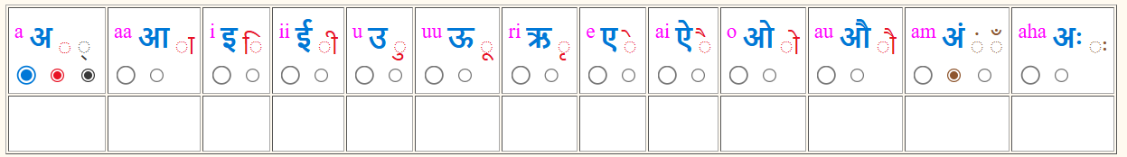

Vowels Matras Halant Ayogavaha
(Anusvara, Chandrabindu, Visarga)

Consonants and Ardha vyanjans 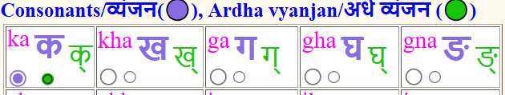

Consonant Ardha vyanjan
Notice that the radio buttons have matching colors as the text.
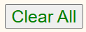
Clacking this button n clears all Radio button selections.

Player

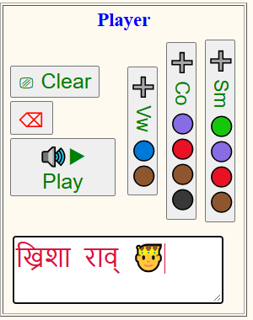
Append a Vowel /With Ayogavaha to Play Buffer
Play Sounds for the text in Play Buffer.
Editable Play Buffer
Backspace. Erase last character in the Play Buffer.
Append a Samyuktakshar with Marta/ +Ayogavaha to Play Buffer

Append a Consonant with Marta/ +Ayogavaha /+Halant to Play Buffer

Clear entire Play Buffer.

Grammar Rules
For Vowels, Vowels (🔵) and Ayogavaha (🟤) are allowed. Examples, ई, ऊँ
For Consonants, Consonants (🟣), Matras (🔴), Halant (⚫), Ayogavaha (🟤), and are allowed. Examples, राम् शंकर
For Samyuktakshars, Ardha vyanjans (🟢), Consonants(🟣), Ayogavaha (🟤), and Matras (🔴) are allowed. Examples, श्याँ

Numerals
The numbers can be entered into the input box. Clicking the “Display Button” prints the number and populates its hindi text in the “Play Buffer” for audio sound as shown below.
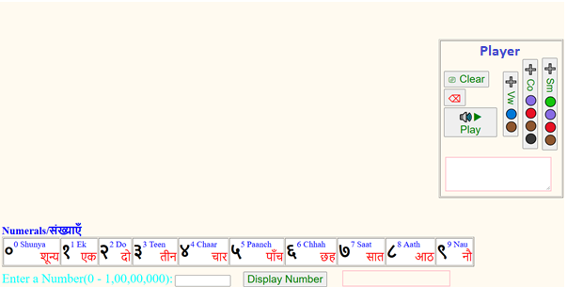
Shows Hindi number text. E.g. shunya

Shows Hindi number. E.g, ०
Enter a decimal number. E.g, 0

Use cases
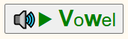
Prints Vowels and Plays associated sound.
✅ Vowels (🔵)
❌ Consonants(🟣)
❌ Ardha vyanjans (🟢)
✅ Ayogavaha (🟤)
❌ Matras (🔴)
❌ Halant (⚫)

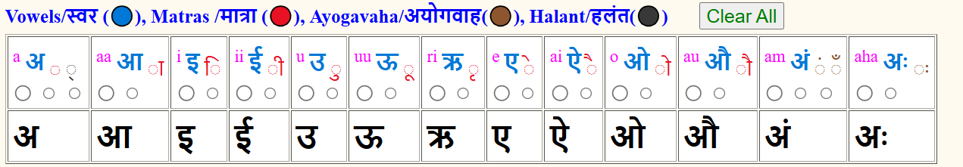

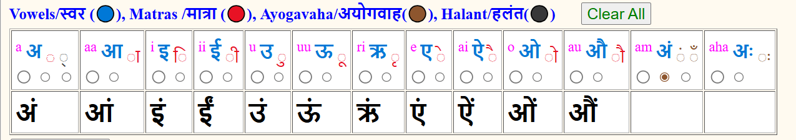
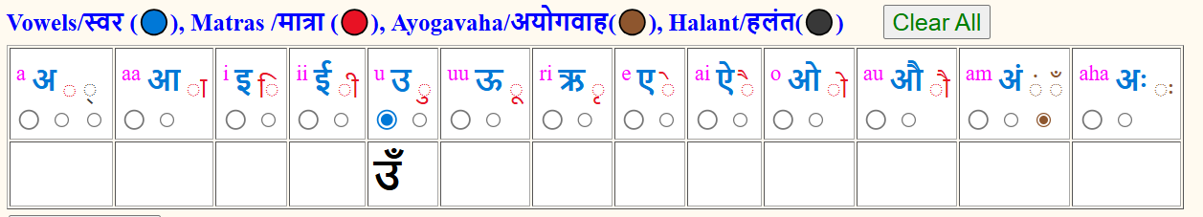

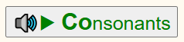
Prints Consonants and Plays associated sound.
❌ Vowels (🔵)
✅ Consonants(🟣)
❌ Ardha vyanjans (🟢)
✅ Ayogavaha (🟤)
✅ Matras (🔴)
✅ Halant (⚫)

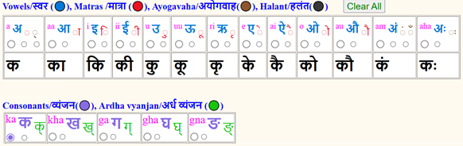
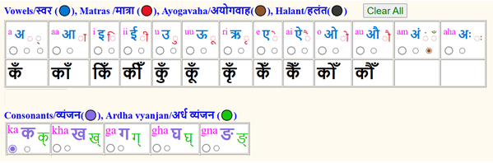
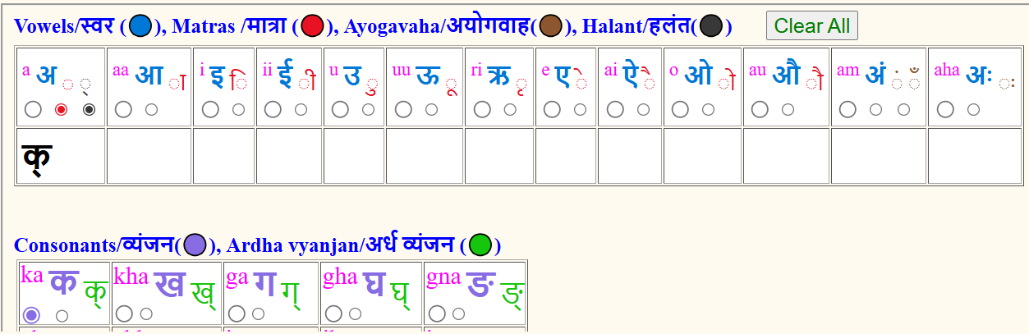
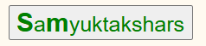
Prints Samyuktakshars only.
❌ Vowels (🔵)
✅ Consonants(🟣)
✅ Ardha vyanjans (🟢)
✅ Ayogavaha (🟤)
✅ Matras (🔴)
❌ Halant (⚫)

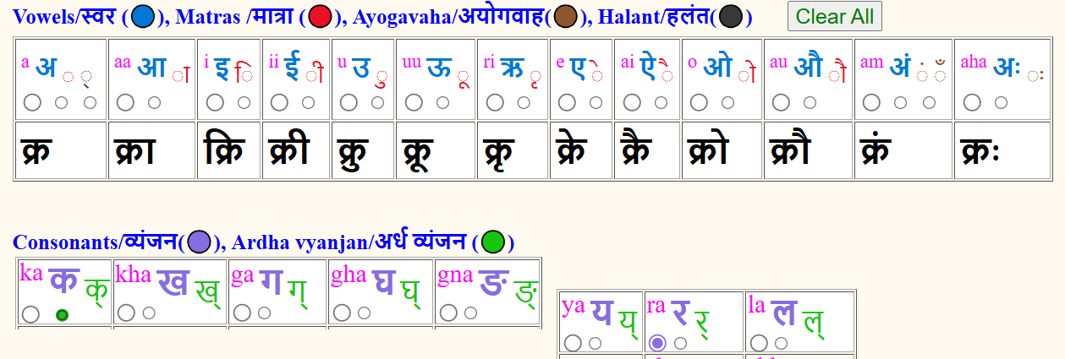
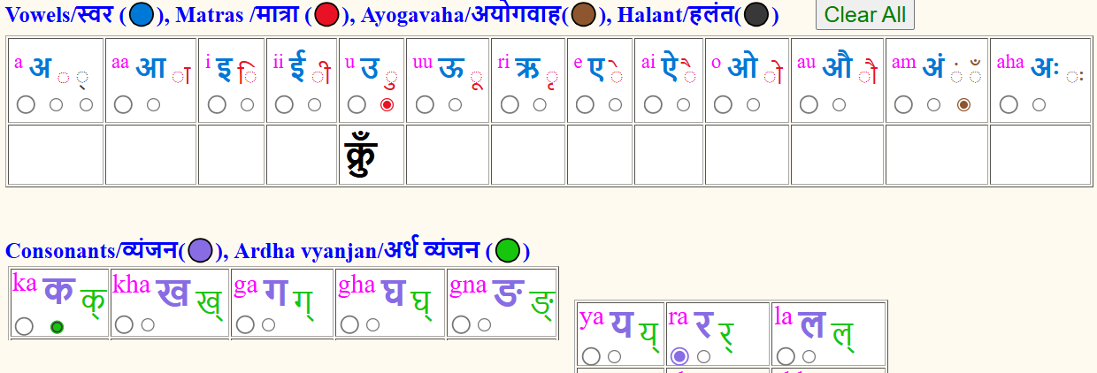

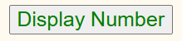
Converts decimal number into Hindi number and hindi text for the same.
